Assigment no 1
Web programming

Name : umar ahad uddin ahmed usmani
Sap : 60199

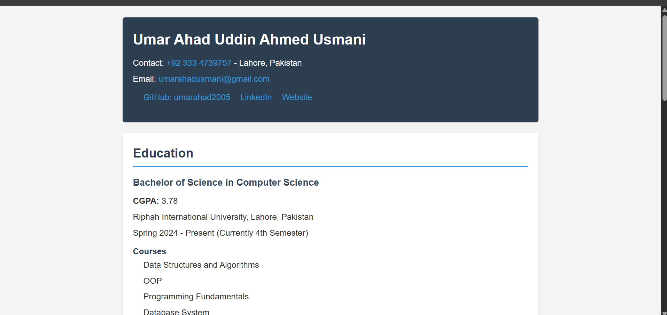

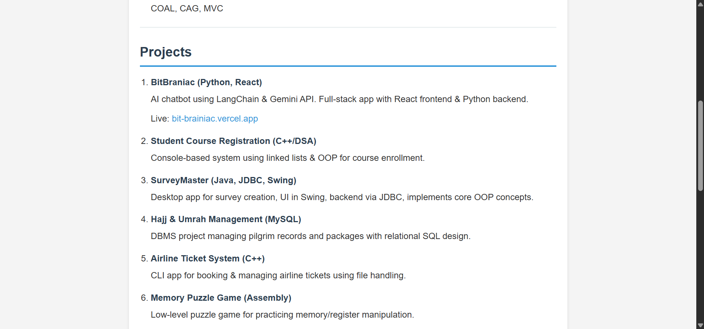

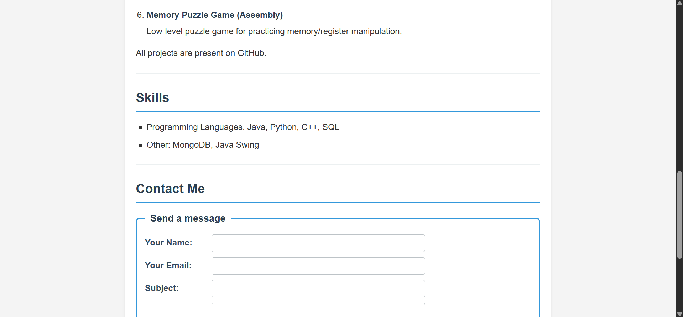

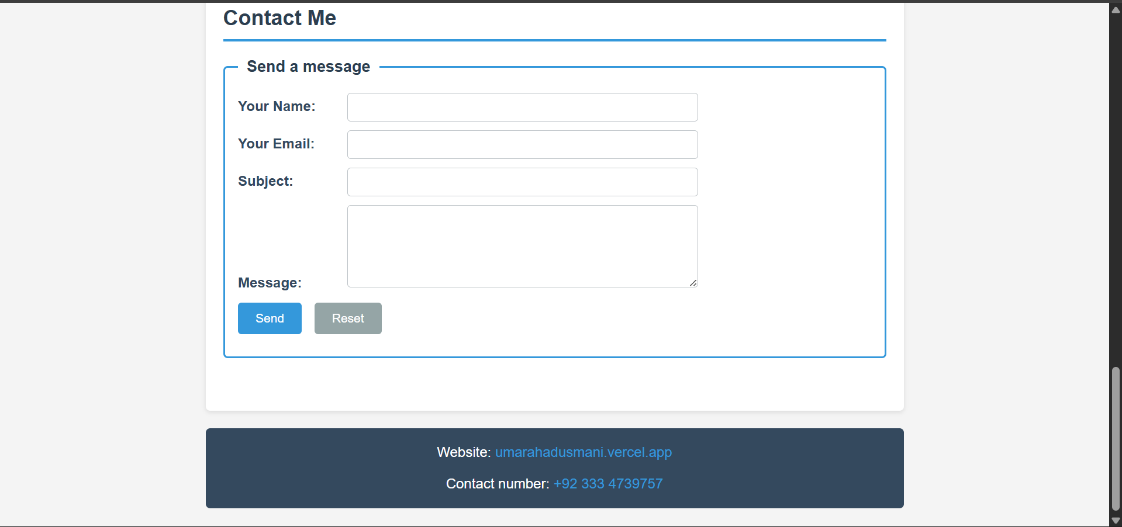

Here is the code
<!doctype html>
<html lang="en">
<head>
<meta charset="utf-8">
<meta name="viewport" content="width=device-width,initial-scale=1">
<title>Umar Ahad Usmani - CV</title>
<meta name="description" content="Simple HTML CV for Umar Ahad Usmani">
<link rel="stylesheet" href="cv.css">
</head>
<body>
<div align="center">
<table role="presentation" align="center" width="800">
<tr>
<td align="left">
<header>
<h1>Umar Ahad Uddin Ahmed Usmani</h1>
<p>Contact: <a href="tel:+923334739757">+92 333 4739757</a> - Lahore, Pakistan</p>
<p>Email: <a href="mailto:umarahadusmani@gmail.com">umarahadusmani@gmail.com</a></p>
<nav>
<ul>
<li><a href="https://github.com/umarahad2005">GitHub: umarahad2005</a></li>
<li><a href="https://linkedin.com/in/umarahadusmani">LinkedIn</a></li>
<li><a href="https://umarahadusmani.vercel.app">Website</a></li>
</ul>
</nav>
</header>

<main>
<section id="education">
<h2>Education</h2>
<article>
<h3>Bachelor of Science in Computer Science</h3>
<p><strong>CGPA:</strong> 3.78</p>
<p>Riphah International University, Lahore, Pakistan</p>
<p>Spring 2024 - Present (Currently 4th Semester)</p>
<dl>
<dt>Courses</dt>
<dd>Data Structures and Algorithms</dd>
<dd>OOP</dd>
<dd>Programming Fundamentals</dd>
<dd>Database System</dd>
<dd>COAL, CAG, MVC</dd>
</dl>
</article>
</section>

<section id="projects">
<h2>Projects</h2>
<ol>
<li>
<h3>BitBraniac (Python, React)</h3>
<p>AI chatbot using LangChain &amp; Gemini API. Full-stack app with React frontend &amp; Python backend.</p>
<p>Live: <a href="https://bit-brainiac.vercel.app">bit-brainiac.vercel.app</a></p>
</li>
<li>
<h3>Student Course Registration (C++/DSA)</h3>
<p>Console-based system using linked lists &amp; OOP for course enrollment.</p>
</li>
<li>
<h3>SurveyMaster (Java, JDBC, Swing)</h3>
<p>Desktop app for survey creation, UI in Swing, backend via JDBC, implements core OOP concepts.</p>
</li>
<li>
<h3>Hajj &amp; Umrah Management (MySQL)</h3>
<p>DBMS project managing pilgrim records and packages with relational SQL design.</p>
</li>
<li>
<h3>Airline Ticket System (C++)</h3>
<p>CLI app for booking &amp; managing airline tickets using file handling.</p>
</li>
<li>
<h3>Memory Puzzle Game (Assembly)</h3>
<p>Low-level puzzle game for practicing memory/register manipulation.</p>
</li>
</ol>
<p>All projects are present on GitHub.</p>
</section>

<section id="skills">
<h2>Skills</h2>
<ul>
<li>Programming Languages: Java, Python, C++, SQL</li>
<li>Other: MongoDB, Java Swing</li>
</ul>
</section>

<section id="contact">
<h2>Contact Me</h2>
<form action="mailto:umarahadusmani@gmail.com" method="post" enctype="text/plain">
<fieldset>
<legend>Send a message</legend>
<p>
<label for="name">Your Name:</label>
<input type="text" id="name" name="name" required>
</p>
<p>
<label for="email">Your Email:</label>
<input type="email" id="email" name="email" required>
</p>
<p>
<label for="subject">Subject:</label>
<input type="text" id="subject" name="subject">
</p>
<p>
<label for="message">Message:</label>
<textarea id="message" name="message" rows="5" cols="40" required></textarea>
</p>
<p>
<button type="submit">Send</button>
<button type="reset">Reset</button>
</p>
</fieldset>
</form>
</section>
</main>

<footer>
<p>Website: <a href="https://umarahadusmani.vercel.app">umarahadusmani.vercel.app</a></p>
<address>Contact number: <a href="tel:+923334739757">+92 333 4739757</a></address>
</footer>
</td>
</tr>
</table>
</div>
</body>
</html>

* {
margin: 0;
padding: 0;
box-sizing: border-box;
}

body {
font-family: Arial, sans-serif;
line-height: 1.6;
color: #333;
background-color: #f4f4f4;
padding: 20px;
}

header {
background-color: #2c3e50;
color: white;
padding: 20px;
border-radius: 5px;
margin-bottom: 20px;
}

header h1 {
font-size: 28px;
margin-bottom: 10px;
}

header p {
margin: 5px 0;
}

header a {
color: #3498db;
text-decoration: none;
}

header a:hover {
color: #5dade2;
text-decoration: underline;
}

nav ul {
list-style: none;
margin-top: 10px;
}

nav ul li {
display: inline-block;
margin-right: 15px;
}

main {
background-color: white;
padding: 20px;
border-radius: 5px;
box-shadow: 0 2px 5px rgba(0, 0, 0, 0.1);
}

section {
margin-bottom: 25px;
padding-bottom: 15px;
border-bottom: 2px solid #ecf0f1;
}

section:last-child {
border-bottom: none;
}

section h2 {
color: #2c3e50;
font-size: 24px;
margin-bottom: 15px;
border-bottom: 3px solid #3498db;
padding-bottom: 5px;
}

article h3 {
color: #34495e;
font-size: 18px;
margin-bottom: 8px;
}

article p {
margin: 5px 0;
}

dl {
margin-top: 10px;
}

dt {
font-weight: bold;
margin-top: 10px;
color: #2c3e50;
}

dd {
margin-left: 20px;
margin-bottom: 5px;
}

ol, ul {
margin-left: 20px;
margin-top: 10px;
}

ol li, ul li {
margin-bottom: 15px;
}

ol li h3 {
color: #2c3e50;
font-size: 16px;
margin-bottom: 5px;
}

#skills ul {
list-style: square;
}

#skills ul li {
margin-bottom: 8px;
}

form {
margin-top: 15px;
}

fieldset {
border: 2px solid #3498db;
border-radius: 5px;
padding: 15px;
}

legend {
font-weight: bold;
color: #2c3e50;
padding: 0 10px;
font-size: 18px;
}

label {
display: inline-block;
width: 120px;
font-weight: bold;
color: #34495e;
}

input[type="text"],
input[type="email"],
textarea {
width: 100%;
max-width: 400px;
padding: 8px;
border: 1px solid #bdc3c7;
border-radius: 4px;
font-family: Arial, sans-serif;
}

textarea {
resize: vertical;
}

button {
background-color: #3498db;
color: white;
padding: 10px 20px;
border: none;
border-radius: 4px;
cursor: pointer;
margin-right: 10px;
font-size: 14px;
}

button:hover {
background-color: #2980b9;
}

button[type="reset"] {
background-color: #95a5a6;
}

button[type="reset"]:hover {
background-color: #7f8c8d;
}

footer {
background-color: #34495e;
color: white;
padding: 15px;
border-radius: 5px;
margin-top: 20px;
text-align: center;
}

footer a {
color: #3498db;
text-decoration: none;
}

footer a:hover {
color: #5dade2;
text-decoration: underline;
}

address {
font-style: normal;
margin-top: 5px;
}

table {
background-color: transparent;
}

a {
color: #3498db;
text-decoration: none;
}

a:hover {
text-decoration: underline;
}

p {
margin-bottom: 10px;
}



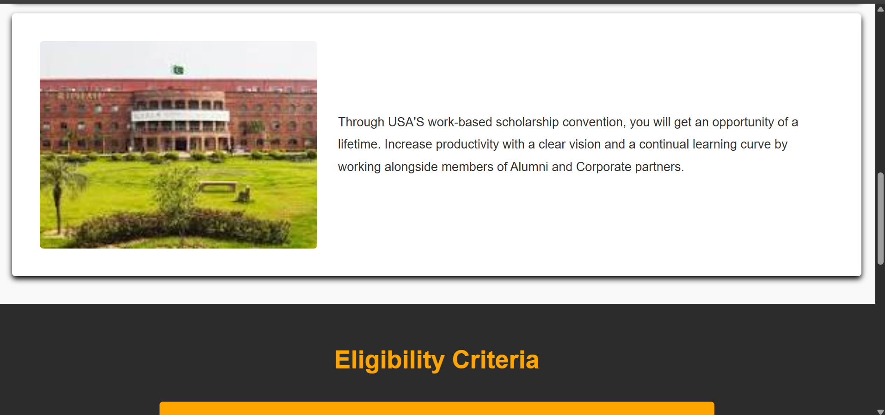

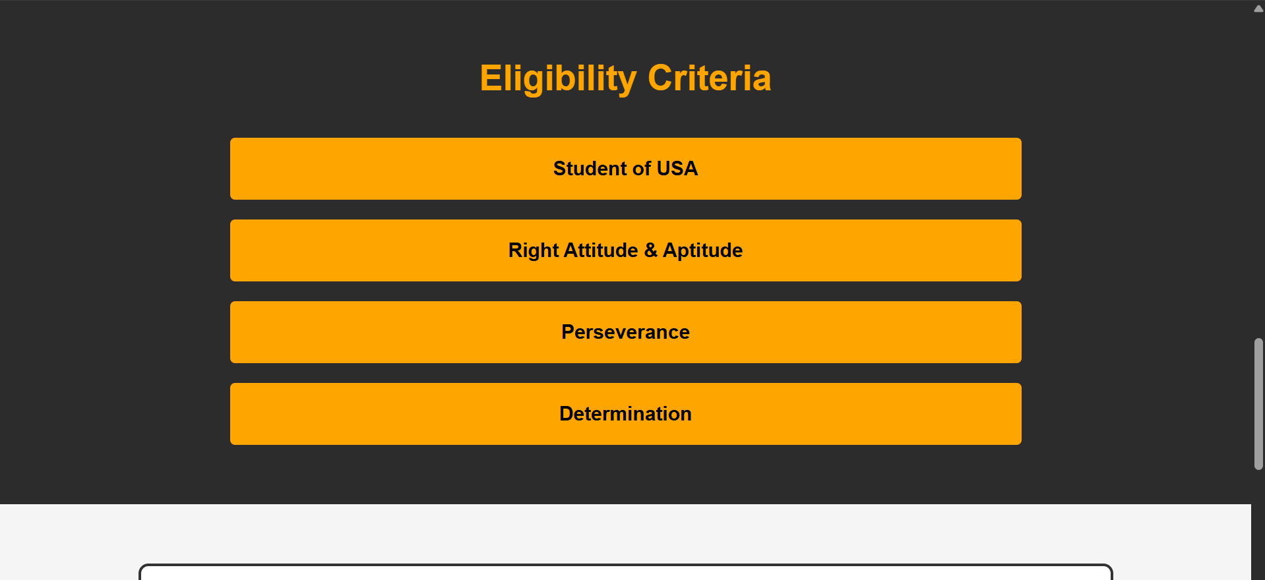

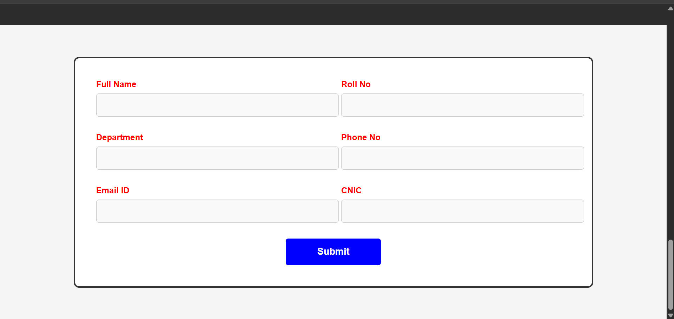

<!DOCTYPE html>
<html lang="en">
<head>
<meta charset="UTF-8">
<meta name="viewport" content="width=device-width, initial-scale=1.0">
<title>Riphah International University</title>
<link rel="stylesheet" href="style.css">
</head>
<body>
<nav class="navbar">
<div class="logo">
<img class="logopic" src="riphah.jpg" alt="logo">
</div>
<div class="nav-links">
<a href="#">Home</a>
<a href="#">About</a>
<a href="#">Contact us</a>
<a href="#">Testimonials</a>

</div>
</nav>
<section class="hero-section">
<div class="content">
<h1>Riphah International</h1>
<p>Register NOW!</p>
<p>Limited seats available!</p>
<button class="register-button">Register Now</button>
</div>

</section>
<section class="second-section">
<div class="para">
<p>If you have the attitude to take on extreme challenges today, you deserve to be part of a promising future tomorrow; a future that will make you financially independent and a successful entrepreneur.</p>
</div>
<div class="para1">
<p>Invest your time and energy for a guaranteed success roadmap, a doorway for venturing into a world of endless possibilities. To become a aspiring entrepreneur, enhance your vision, and be financially independent.</p>
<img src="riphah.jpg" alt="Student studying">
</div>
<div class="para2">
<img src="riphah2.jpg" alt="Professional working">
<p>Through USA'S work-based scholarship convention, you will get an opportunity of a lifetime. Increase productivity with a clear vision and a continual learning curve by working alongside members of Alumni and Corporate partners.</p>
</div>

</section>

<section class="eligibility-section">
<h2>Eligibility Criteria</h2>
<div class="criteria-list">
<div class="criteria-item">Student of USA</div>
<div class="criteria-item">Right Attitude & Aptitude</div>
<div class="criteria-item">Perseverance</div>
<div class="criteria-item">Determination</div>
</div>
</section>

<section class="form-section">
<div class="form-container">
<form>
<div class="form-row">
<div class="form-group">
<label>Full Name</label>
<input type="text" placeholder="" required>
</div>
<div class="form-group">
<label>Roll No</label>
<input type="text" placeholder="" required>
</div>
</div>
<div class="form-row">
<div class="form-group">
<label>Department</label>
<input type="text" placeholder="" required>
</div>
<div class="form-group">
<label>Phone No</label>
<input type="tel" placeholder="" required>
</div>
</div>
<div class="form-row">
<div class="form-group">
<label>Email ID</label>
<input type="email" placeholder="" required>
</div>
<div class="form-group">
<label>CNIC</label>
<input type="text" placeholder="" required>
</div>
</div>
<div class="form-submit">
<button type="submit" class="submit-button">Submit</button>
</div>
</form>
</div>
</section>

</body>
</html>

*{
padding: 0;
margin: 0;
font-family: Arial, Helvetica, sans-serif;
}
.logo{
border-radius: 50%;
}
.logopic{
width: 50px;
}
nav{
display: flex;
background-color: blue;
align-items: center;
padding: 10px 20px;
}
.nav-links{
width: 30%;
display: flex;
justify-content: space-between;
margin-left: 400px;
}
a{
color: white;
text-decoration: none;
font-size: 20px;
}
.hero-section{
background-image: url("riphah2.jpg");
background-size: cover;
background-position: center;
height: 400px;
text-align: center;
display: flex;
align-items: center;
justify-content: center;
}
.hero-section .content h1{
color: whitesmoke;
font-size: 50px;
font-weight: bold;
text-shadow: 2px 2px 4px black;
}
.hero-section .content p{
color: whitesmoke;
font-size: 24px;
margin-top: 10px;
text-shadow: 1px 1px 3px black;
}

.register-button{
background-color: blue;
color: white;
border: none;
padding: 15px 30px;
border-radius: 5px;
cursor: pointer;
font-size: 18px;
margin: 20px;
font-weight: bold;
}
.register-button:hover{
background-color: darkblue;
}
.second-section{
padding: 20px;
background-color: #f9f9f9;
}
.para{
text-align: center;
padding: 20px 40px;
background-color: lightgray;
font-size: 16px;
color: black;
line-height: 1.6;
box-shadow: 0px 4px 8px black;
margin: 20px auto;
max-width: 1200px;
border-radius: 5px;
}
.para1{
display: flex;
align-items: center;
padding: 40px;
background-color: white;
gap: 30px;
margin: 20px auto;
max-width: 1200px;
box-shadow: 0px 4px 8px black;
border-radius: 5px;
}
.para1 p{
flex: 1;
font-size: 18px;
line-height: 1.8;
text-align: left;
color: #333;
}
.para1 img{
width: 400px;
height: 300px;
object-fit: cover;
border-radius: 5px;
}
.para2{
display: flex;
align-items: center;
padding: 40px;
background-color: white;
gap: 30px;
margin: 20px auto;
max-width: 1200px;
box-shadow: 0px 4px 8px black;
border-radius: 5px;
}
.para2 img{
width: 400px;
height: 300px;
object-fit: cover;
border-radius: 5px;
}
.para2 p{
flex: 1;
font-size: 18px;
line-height: 1.8;
text-align: left;
color: #333;
}

.eligibility-section{
background-color: #2c2c2c;
padding: 60px 40px;
text-align: center;
}
.eligibility-section h2{
color: orange;
font-size: 36px;
margin-bottom: 40px;
font-weight: bold;
}
.criteria-list{
display: flex;
flex-direction: column;
gap: 20px;
max-width: 800px;
margin: 0 auto;
}
.criteria-item{
background-color: orange;
color: black;
padding: 20px;
font-size: 20px;
font-weight: bold;
border-radius: 5px;
}

.form-section{
background-color: #f5f5f5;
padding: 60px 40px;
}
.form-container{
max-width: 900px;
margin: 0 auto;
background-color: white;
padding: 40px;
border: 3px solid #333;
border-radius: 10px;
}
.form-row{
display: flex;
gap: 30px;
margin-bottom: 30px;
}
.form-group{
flex: 1;
}
.form-group label{
display: block;
color: red;
font-size: 16px;
margin-bottom: 8px;
font-weight: bold;
}
.form-group input{
width: 100%;
padding: 12px;
border: 1px solid #ccc;
border-radius: 5px;
font-size: 16px;
background-color: #f9f9f9;
}
.form-submit{
text-align: center;
margin-top: 20px;
}
.submit-button{
background-color: blue;
color: white;
border: none;
padding: 15px 60px;
border-radius: 5px;
cursor: pointer;
font-size: 18px;
font-weight: bold;
}
.submit-button:hover{
background-color: darkblue;
}

@media (max-width: 992px) {
.nav-links {
margin-left: 100px;
width: 50%;
}
a {
font-size: 18px;
}

.hero-section {
height: 300px;
}
.hero-section .content h1 {
font-size: 36px;
}
.hero-section .content p {
font-size: 20px;
}

.para1, .para2 {
gap: 20px;
padding: 20px;
}
.para1 img, .para2 img {
width: 300px;
height: 220px;
}

.form-row {
gap: 15px;
}
}

@media (max-width: 768px) {
nav {
flex-direction: column;
text-align: center;
}
.nav-links {
flex-direction: column;
width: 100%;
margin-left: 0;
gap: 10px;
}

.hero-section {
height: auto;
padding: 40px 10px;
}
.hero-section .content h1 {
font-size: 28px;
}
.hero-section .content p {
font-size: 18px;
}

.para1, .para2 {
flex-direction: column;
text-align: center;
}
.para1 img, .para2 img {
width: 100%;
height: auto;
}

.eligibility-section h2 {
font-size: 28px;
}
.criteria-item {
font-size: 18px;
}

.form-container {
padding: 20px;
}
.form-row {
flex-direction: column;
}
.submit-button {
width: 100%;
}
}
@media (max-width: 480px) {
.logopic {
width: 40px;
}
a {
font-size: 16px;
}

.hero-section .content h1 {
font-size: 22px;
}
.hero-section .content p {
font-size: 14px;
}

.para, .para1, .para2 {
padding: 10px;
}
.para1 p, .para2 p {
font-size: 16px;
}

.form-group label {
font-size: 14px;
}
.form-group input {
font-size: 14px;
padding: 10px;
}
.submit-button {
font-size: 16px;
padding: 12px 30px;
}
}

